## The Thirty-year Discussion: On the nonlinear relationship between ‘job fitness’ (including physical fitness) and employability

### Introduction

The previous section has suggested that politicians were perhaps too ready to accept and promote evidence appearing to support Pathway’s claims to efficacy, and conversely too willing to overlook or bury evidence challenging these claims. As well as the usual ‘face-saving’ explanations for this asymmetry – politicians, like everyone else, tend to have a self-serving bias in interpreting the effects of their own actions; and politicians, like many other people in competitive occupations, tend to be attacked particularly severely by rivals if and when their actions are seen to be failing – in the case of incapacity benefits, broader structural and historical factors also matter. As I showed in chapter 8, over the past three decades, and in particular since the end of the 1980s, there has been a very substantial increase in the numbers of people claiming IVB/IB, with rates roughly doubling from about 30 to 60 per thousand persons of working age from the mid-1980s to mid-1990s . Within that chapter, in my replication and updating of Bartley & Owen’s 1996 British Medical Journal article, (pages 128-137) I also showed that, for men of working age, the strength of the correlation between employment rates and inactivity rates is much stronger for those reporting longstanding limiting illness than for those without, suggesting that decreases in employment levels lead to increasing levels of economic inactivity. For men especially (but increasingly so for women too) this economic inactivity took the form of IB receipts. The chapter also showed that, for both males and females of working age, the IB claimant population is drawn disproportionately from those nearer the end of the working age range, indicating that, for many, IB functions as a form of ‘early retirement’ benefit.

I think these findings all point in the same direction, and can be largely explained by assuming that *there is a nonlinear relationship between employment ‘fitness’* (how well or poorly a candidate compares to others when being assessed for a particular job) *and employability* (the ease or difficulty a candidate faces in getting a job). For this section of the conclusion, I want to describe and explain the nature and causes of this nonlinear relationship, by formalising a number of assumptions about the ‘fitness’/employability into a very simple statistical model. This model is based substantially on Beatty, Fothergill, & MacMillan’s *Theory of Employment, Unemployment and Sickness*,[1] and I believe can be seen as supporting a ‘demand-side’, rather than ‘supply-side’, explanation for much of the increase in the rates of IVB/IB that occurred over the last thirty years.

### The Model

The assumptions I make in constructing the model are as follows:

1. Jobs are allocated through a first-past-the-post selection process. This means employers, when selecting a candidate for a job, choose who they believe to be the ‘best’ candidate for the job, rather than, for instance, allocating fractions of a job in proportion to the relative perceived fitness of the candidates. In the model, this is represented by positing a ‘job fitness’ axis, with ‘worst candidate imaginable’ at one and of the axis, ‘best candidate imaginable’ at the other end, and all actual levels of perceived job fitness lying somewhere between these two extremes.
2. There is a level of variability and inconsistency in the level of apparent job fitness an applicant has for a job. For example, on some occasions he may appear a particularly good candidate for a job (Perhaps he woke up especially rested, or heard something on the radio that happened to bolster his confidence just before the interview, or perhaps the employer interviewing him happened to like what he was wearing because he was dressed like someone the employer knew and liked); and on others he may appear a particularly bad candidate (Perhaps he shares the same first name as someone whom the employer dislikes, or perhaps he had had a particularly stressful conversation with a spouse or sibling immediately prior to the interview, or perhaps he tripped when attempting to greet the interviewer, and so made a particularly poor first impression). In the model this is represented by imagining that an applicant’s apparent job fitness follows a Normal distribution curve.
3. Each job applicant also has an *average* level of apparent job fitness, a central level of apparent fitness around which displays of fitness (i.e. performance in applications for jobs) tend to converge. Again, this is represented using a Normal distribution curve.

Visually, this is shown in Figure 12.8, in which the fitness distribution of two applicants, A and B, are shown using the blue and red Normal distribution curves, respectively. For simplicity, the variance of both applicants’ distributions are assumed to be identical, but the theoretical mean of B’s performance is lower than A’s. This difference in means is B’s *fitness disadvantage* relative to A, and is represented by the letter *d.*

Figure .8 Example of job selection process with two candidates for four jobs (Original image in colour)

**Employer’s appraisal of candidate’s job fitness**

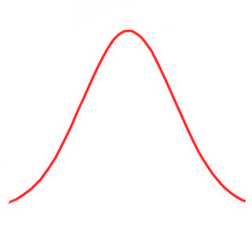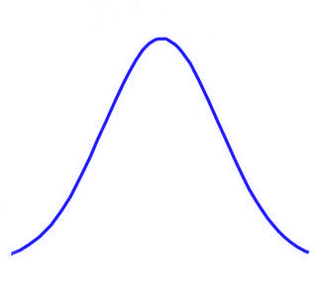

B

A

*d*

***Job 1***

***Job 2***

***Job 3***

***Job 4***

*Terrible*

*Fantastic*

As a simple illustration of the process, below the curves, I have shown how A and B might perform on four separate occasions, when both applying for the same job, for which there are no other candidates. On each occasion, a random draw is taken from the applicant’s distribution, and the candidate with the highest score is selected for the job (represented using the dashed box). In this illustration, candidate A, the non-disadvantaged candidate, gets the job on three occasions, and B, the disadvantaged candidate, gets the job on one occasion (in which B performed significantly above expectation, and A performed significantly below expectation).

Note, from this diagram, that the likelihood of a candidate getting a job does not depend upon the *absolute* position of the candidate’s draw on the job fitness axis (i.e. *all* candidates for the job could be either very good or very bad candidates, in objective terms), but instead entirely on the candidate’s position *relative* to other candidates.

In this model, what I want to explore are the effects of job competition, and the effects of B’s fitness disadvantage (the size of *d*) on the probability of getting a job (i.e. coming first in the queue). To simulate the effect of job completion, I simply take *k* draws (rather than just one draw) from distribution A, to represent the apparent fitness of *k* equally non-disadvantaged candidates in getting a particular job, in addition to one draw from distribution B. To simulate the effects of fitness disadvantage, I vary the distance *d*, to increase or decrease the amount of overlap between the distributions.

Repeating this process many times,[2] for , and $d ∈ \left\{0.0, 0.1, 0.2, …, 4.9\right\}σ$ (i.e. for between 1 and 15 job rivals; and for between no disadvantage, and for a disadvantage equal to almost five standard deviations below the average fitness of A), produces a set of estimated probabilities of B getting a job under each of these scenarios. The reciprocal of this probability is thus the expected number of interviews B would need in order to get a job (For example, if a candidate has a 25% probability of getting a job then the expected number of interviews required will be 4). In Figure 12.9 below, I present B’s *job fitness* disadvantage, *d,* on the vertical axis, and the expected number of interviews needed to get a job, a measure of *employability*, on the horizontal axis. I plot this relationship for k = 1, 3, 5, 10, and 15.

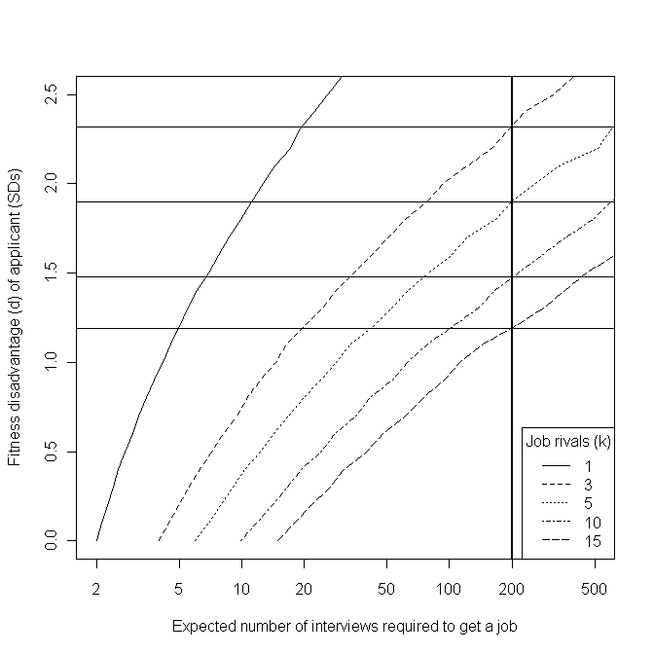Figure .9 Predicted relationship between job 'fitness', number of rivals, and employability

Note that I have used a log-scale on the horizontal axis, but a linear scale on the vertical axis. For reference, I have indicated the level of fitness disadvantage expected to result in an employability level of, on average, one job offer per 200 applications: a level of failure that would be extremely disheartening, and effectively close to ‘unemployable’.[3]

The relationship between employability and job fitness (the horizontal and vertical axes) is approximately log-linear. The effect of increased competition, however, is to shift this log-linear relationship towards the bottom-right corner of the graph, *so that the same level of job fitness disadvantage results in exponentially increasing levels of employability disadvantage*. In times of greater job scarcity, slight disadvantages in job fitness (which in the case of manual labour occupations, especially, includes physical fitness) result in extremely severe disadvantages in labour market employability. In these more competitive situations, even if a disadvantaged candidate *could do* a job, he or she has a vanishingly small chance of *being allowed to do* so.

### Objections and Provisos

The model described above is highly simplistic, and so the objection could be raised that it is insufficiently *realistic*, and either ignores extremely important factors involved in real-life recruitment processes, or misrepresents such processes to such an extent that the results that follow from the model, and the qualitative interpretation I have offered of these results, are technical artefacts of the way in which I operationalised and formalise the problem, rather than something with substantive meaning. As with many technical models of this sort, countless iterations and variations of the basic set-up could be produced: the variance of different candidates’ apparent fitness could be allowed to vary, rather than be assumed the same for everyone; the effects of constant and persistent rejection could be assumed to have some effect on B’s average performance, either reducing *d*, as B gains increased practice and experience at performing at interviews, or increasing *d,* as B becomes increasingly disillusioned, demotivated, and despondent as job-search efforts fail to yield noticeable rewards; and so on and so on.

Attempting to ‘correct for’ and investigate the effects of these various modelling assumptions could very easily be made to occupy a lot of time and space: a three page description could conceivably be turned into a thirty page paper, or even a three-hundred page thesis. In doing so, an issue of substantive social importance becomes reinterpreted as a set of technical challenges, with the models becoming ever more complicated and unintuitive, and in the process abstracted and rarefied to such an extent that any insight the model originally brought to the social phenomena it was inspired by becomes buried under a mass of graphs and equations. The abstract machine becomes overloaded, until it collapses in on itself.

Accepting this proviso, I now want to briefly discuss verbally, rather than formalise algebraically, a number of issues that I think are important in job-selection processes, but which are not represented in the model. At the end of each description, I will suggest how I think attempting to represent these issues may alter the model results, and if so whether it would change the overall interpretation of the model.

* **Conventions and Codes filter candidates prior to fitness assessment:** For example, a company might state in a job advert that applicants need to have either a first or upper-second class degree to be considered for interview (a code), and apply this rule unfailingly. Or, the human resources manager of a company may adopt a number of heuristics (conventions), such as “Don’t interview anyone over 50”, “Don’t interview anyone with a gap in their employment record of more than six months”, “Don’t interview anyone who ticks the box saying they have a criminal record”, and so on, and apply these conventions as informal (and perhaps technically illegal) decision-rules, just as in the prior example a code was used as a decision-rule. I believe that, if this process were also included in the model, then the likely result would be to further *increase,* rather than *decrease,* the employability disadvantage faced by disadvantaged applicants, and so would not invalidate the arguments I have made above.
* **Temp Agencies:** For many, if not most, low-paid jobs, employment is not secured through interviews or recruitment processes conducted by the employers themselves, but through temp agencies and similar human resource brokerage services. This may modify the process modelled slightly, but not, I believe, substantially. Whenever someone contacts a temp agency in need of a job, the employee at the temp agency will likely attempt to judge and assess that person as she believes the employers whom the agency services would, to imagine herself in the position of an employer on her books, and assess them in terms of suitability (‘fitness’) for the vacancies she has been asked to fill. Only those temps who are seen as ‘best’ for a vacancy would then be matched with employers and given a chance to work. In this sense, the temp agency employee acts as a kind of surrogate interviewer for the employer, and so exactly the same argument applies. (The ‘casual’ and ‘flexible’ nature, and low pay, of most of the jobs temp agencies offer, however, perhaps does function to decrease the number of candidates per vacancy.)
* **Local Fitness Disadvantage:** Perhaps, in a certain region, a large proportion of the local workforce have a substantial job fitness disadvantage, relative to a nationally or internationally ‘average’ candidate. If there were little or no labour market mobility from region to region, the low regional fitness of candidates would not lead to these candidates suffering from a severe employability disadvantage, as they would not be disadvantaged relative to most other applicants (i.e. they would all be more like candidate A rather than candidate B, but A’s mean fitness would be lower). Where labour market mobility increases, however, this regional fitness disadvantage quickly becomes a very severe employability disadvantage, as the pool of rivals expands to include more people from other parts of the country, and from other countries. Where there are vast disparities in average wages between regions, or between countries, then people from poorer areas, and poorer countries, tend to be willing to travel increasing distances in search of better paying work. Immigrant labour, either from other regions or other countries, will tend to be ‘fitter’ (younger, stronger, healthier, better motivated, better prepared to work for what locals consider low wages), from the employers’ perspective, than local labour, and so, through the processes described in the model, increased immigration can effectively render large sections of the local workforce ‘unemployable’.
* **Homophily:** Perhaps employers are not as rational or calculating as I have assumed in the model. Instead, perhaps employers tend to want to pick employees who are like themselves, and not pick employees who are substantially different from themselves. Assuming that a large proportion of selection is based on homophily and the properties of social networks and group identities, rather than a rational scale of apparent job fitness, would lead to a substantially different model to that which I have discussed in this section. It could either exacerbate, or it could ameliorate, the fitness/employability relationship described here. Perhaps if the managers of a company are in their sixties, male, and working class, then they will treat older, male, working class candidates preferentially. If most of the managers are middle-class thirty-something university-educated females, however, then the converse may occur. Homophilic selection might be thought of as a much more dominant mechanism than fitness selection, or it might be seen as a fundamentally a modifier of fitness selection rather than a genuine alternative (‘people like us’ get moved forward in the queue, but not so far that they are guaranteed a job), or perhaps the two mechanisms could be imagined to interact in some way, to produce a hybrid model (perhaps with different streams of job offered for homomorphic as against heteromorphic candidates). The issue of homophily in employment is very important, but I expect not so fundamentally that the argument developed in the fitness model is not credible.

### Concluding Remarks

My main aim in creating and describing the model presented above was to explore a few intuitions I had about *why* having a slight but noticeable impairment relative to others in the labour market might lead to people becoming, effectively, ‘unemployable’. In doing so, I have indicated why what have been called demand-side explanations for the rapid rise in incapacity benefit claimant rates since the late 1980s may be much more important than many politicians appear to assume.

As David Webster, an economic geographer and director of housing services at Glasgow City Council suggests, the government “is very confident that the problem lies entirely on the supply side of the labour market. In other words it is caused by the characteristics or motivation of workless people and not by any shortage of demand for labour”.[4] Webster suggests that “government focus on supply-side explanations of worklessness has led to supply-side labour market policies [such as the] development of a more proactive employment service, oriented towards identifying people’s labour market handicaps and helping to remedy them”.[5] Conversely, demand-side policies – such as providing sheltered employment opportunities for those with fitness disadvantages that, in a more competitive labour market, effectively renders them unemployable through usual selection processes; or subsidising employers to keep or take on employees with fitness disadvantages - have been persistently avoided, and demand-side ‘legacy’ organisations, such as Remploy, which was established in 1945 to provide sheltered employment for disabled people, have been forced to shed thousands of jobs.[6]

The broader reasons for avoiding demand-side interventions seem to be ideological. Demand-side interventions, the extension of the State’s role in the production of goods and services, have, until the global financial crisis which began in late 2008, been rejected as deleterious distortions of the Economy, that should be avoided except where completely necessary, because they reduce the ‘efficiency’ with which the market operates. In many cases, the government’s belief in the comparative ‘inefficiency’ of public sector organisations has led them to encourage private and third sector organisations to take over the provision of public *services* that previously were provided by the public *sector.* John Kay, an economist who has actually worked in the private sector, rather than exclusively in academia, has suggested that: “There is something of the zeal of the convert in [New Labour’s] embrace of the market.” [7]

In the case of *Pathways to Work*, this zeal has led to the use of private- and third-sector organisations to deliver Pathways in the majority of the country,[8] even though all of the pilot studies were conducted using public sector Jobcentre Plus, and so the effectiveness of private- and third-sector organisations’ provision is unknown. According to at least one academic article, this contacting out of public services to the private and third sector is fairly typical, despite there being little or no evidence that such contractors are any more effective at providing public services than the public sector.[9] It follows from a belief in the superior efficiency of the unfettered market, however, that these providers do not have to be evaluated with the same level of scrutiny as the public sector, because they can simply assumed to be more effective and efficient in providing *any* goods and services, including public goods and public services. The measured effectiveness of the public sector, therefore, can be assumed to represent a ‘worst-case scenario’ for the effectiveness of the private and third sector in providing the same services.

Of the private sector and the third sector, the government seems to prefer the former, presumably because they are thought to respond better to the financial incentives that are thought to be key to the efficiency of the free markets.[10] Perhaps, given the global financial crisis which began in 2008, these kinds of beliefs, which emphasise supply-side labour market policies at the expense of demand-side policies, will not be held with the same degree of conviction by future governments.

1. Beatty, C., S. Fothergill and R. Macmillan (2000). "A Theory of Employment, Unemployment and Sickness." Regional Studies **34**(7): 617-630.
2. In my model, I have replicated the results using each combination of *k*  and *d* 100,000 times, to average out the stochastic uncertainty in the results. It would be possible to arrive at these conclusions analytically rather than through simulation, but I do not believe the results would be qualitatively any different.
3. A different threshold could be used if the one-in-200 level is seen as either too high or too low, but the same overall argument still applies.
4. Webster, D. (2006). "Welfare Reform: Facing up to the Geography of Worklessness." Local Economy **21**(2): 107-116., p. 107
5. Ibid., p. 114
6. Davies, C. (2008). "Job losses are 'betrayal' of disabled: Unions protest after the government refuses to rescue factories that keep thousands in work." Retrieved 12 April, 2009, from http://www.guardian.co.uk/society/2008/mar/09/disability.
7. Kay, J. (2007, August). "The Failure of Market Failure." Prospect Magazine. Retrieved 12 April, 2009, from http://www.prospect-magazine.co.uk/pdfarticle.php?id=9709.
8. The DWP distinguishes between ‘Jobcentre Plus led Pathways to Work’, which includes the pilot studies, and ‘Provider led Pathways to Work’. According to a brief statement on a DWP website: “From April 2008, in [...] 60 per cent of the country Pathways to Work has been delivered by external contractors.” DWP. (2008). "Pathways to Work Process." Retrieved 12 April, 2009, from http://www.dwp.gov.uk/welfarereform/pathways_process.asp.
9. Davies, S. (2008). "Contracting out employment services to the third and private sectors: A critique." Critical Social Policy **28**(2): 136-164.
10. For example, the response provided by the DWP to the question, “How many third sector prime contractors and subcontractors are currently involved in the delivery of DWP-funded employment programmes?” at a Work and Pensions Committee was “DWP currently has just under 600 providers delivering DWP funded employment programmes *of which 30% are Third Sector”* [Emphasis added]. [Source: www.parliament.uk. (2009, 5 March). "'Supplementary memorandum submitted by the Department for Work and Pensions’, DWP’s Commissioning Strategy and the Flexible New Deal – Work and Pensions Committee." Retrieved 12 April, 2009, from http://www.publications.parliament.uk/pa/cm200809/cmselect/cmworpen/59/59we28.htm.